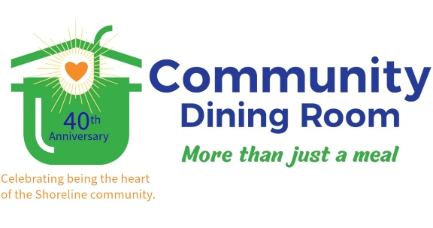

**BACKPACK PROGRAM 2025**

**FREQUENTLY ASKED QUESTIONS**

**Who can receive a backpack through this program?**

* Branford students with proof of family income and Branford residence are eligible to receive a free backpack.

**Does the student need to attend Branford Public Schools?**

* No, all students who reside in Branford are eligible regardless of their school of attendance.

**How do I prove income eligibility?**

* As part of the application process, please upload a copy of your State of Connecticut Department of Social Services Connect card OR your student’s HUSKY card.

**How do I fill a backpack?**

* Just complete the “fill a backpack” form and we’ll send you a number for your unique student and a list of required supplies for that student’s grade level. Shop for your student(s), put the number on the outside of the bag or box of supplies, and drop it off at the dining room! We’ll take it from there.

**Should I add other items for my student?**

* To avoid disparities between children or within families, please purchase only what’s on the supply list. We truly appreciate your generosity!

Any other questions? Please email Program Coordinator Jane Ferrall, [programcoordinator@communitydiningroom.org](mailto:programcoordinator@communitydiningroom.org) or call her at 203-488-9750 Ext. 2